Five Things to Do While You Wait
BY RICK WARREN — JANUARY 23, 2016

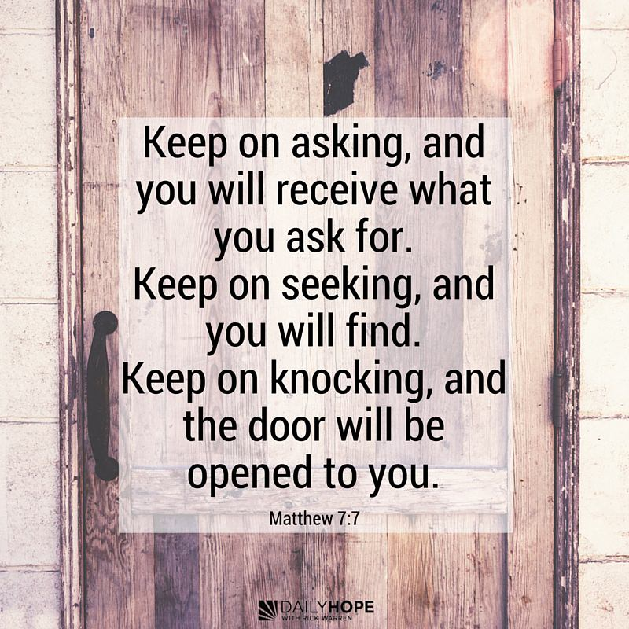

“Keep on asking, and you will receive what you ask for. Keep on seeking, and you will find. Keep on knocking, and the door will be opened to you.” (Matthew 7:7 NLT, second edition)
When God has you in a waiting period, don’t put your life on hold. Instead, imitate the habits that grow strong faith.

The Bible says there are five things you should keep on doing even in the waiting period.
- Keep on praying. The Bible says, “Keep on asking, and you will receive what you ask for. Keep on seeking, and you will find. Keep on knocking, and the door will be opened to you” (Matthew 7:7 NLT, second edition). Keep on praying, and you will get your answer.
- Keep on serving. Romans 12:11 says, “Never be lazy, but work hard and serve the Lord enthusiastically.” Don’t worry about having a significant ministry. Just make your ministry significant.
- Keep on going to small group. The Bible says in Hebrews 10:25, “Let us not give up the habit of meeting together …. Instead, let us encourage one another all the more, since you see that the Day of the Lord is coming nearer” (TEV).
- Keep on sowing. Ecclesiastes 11:6 says, “Keep on sowing your seed, for you never know which will grow —perhaps it all will” (TLB).
- Keep on believing. The Bible says, “You must keep on believing the things you have been taught. You know they are true” (2 Timothy 3:14).
The point is this: Stay active. Don’t be passive. God cannot steer a parked car! Don’t tell God you’re waiting on him. Turn on the ignition, and just start driving. Where? Anywhere! Get involved in a ministry. Get involved in service. Get involved with small group. Do the things you know you could be doing to develop your skills and habits and become more like Jesus.
PLAY today’s audio teaching from Pastor Rick >>
Talk It Over
- How do you tend to react when God has you in a waiting period?
- In what ways does a small group help you become more like Jesus, especially in the waiting periods of life?
- What steps can you take today to be more active about your faith?

